## Part 4: Practice writing SQL.

Write code to:

1. Run ProjectIT – leeds and manchester set up scripts.
2. Create a new database table: ‘new_projects’ with attributes: Week_no, year, no_of_projects
3. Look at the data you have been given (from the ProjectIT scripts) and work out what data will be in the table.
4. Write SQL to SELECT the data to put into the table.
5. Write SQL to INSERT the data into the table.
6. Do further testing, add more rows to the original tables and re-test your queries.

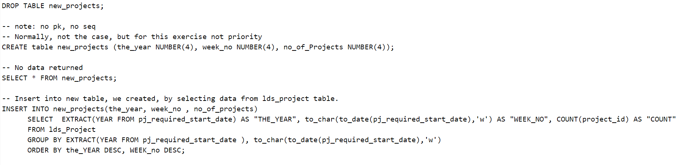

SELECT * FROM new_projects;

Results:

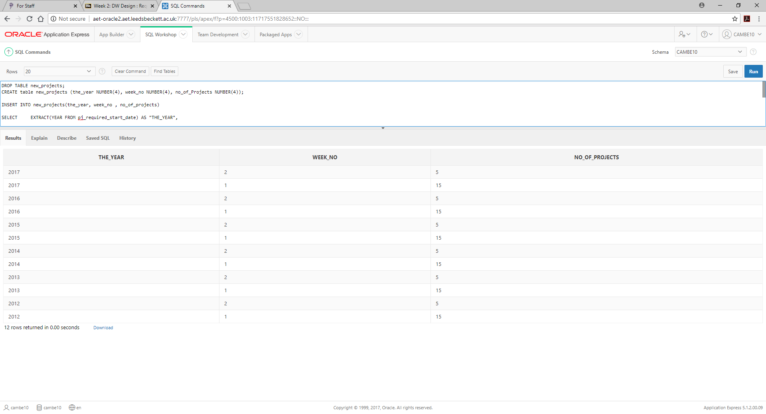

-- Task: redo the insert statement above to insert data from mch_job table. Why this table? If not sure, check with your tutor or look at the assessment data and tables again.

* Start again
* Note that Ive added new field, id in our new_project table



We’ll have to insert data again from leeds first, in reality it does not matter which table we do first. Then add Manchester data.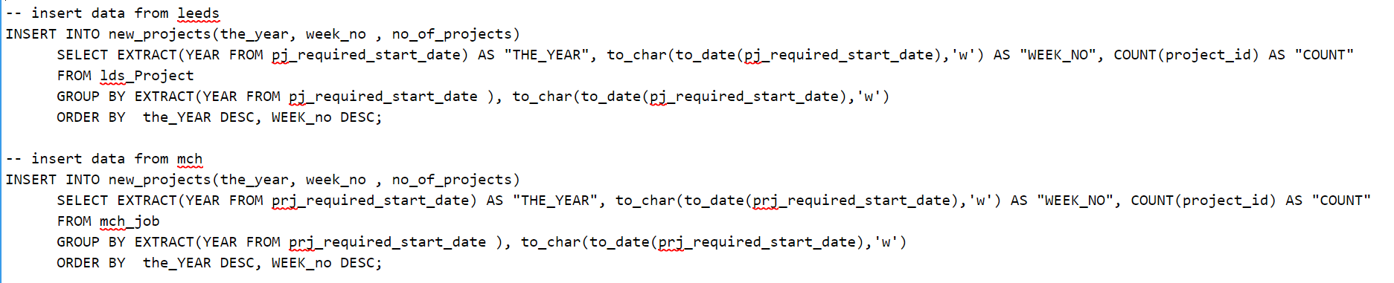

Select the data from new project table will show the following results:

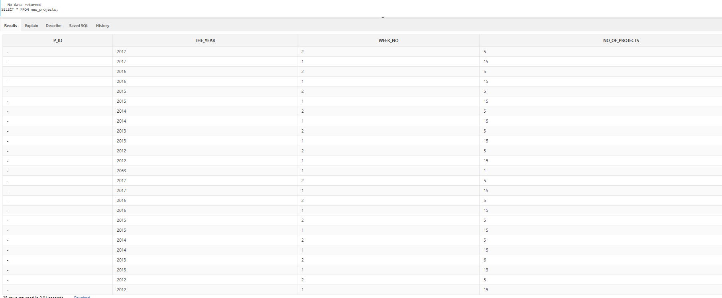

What is next to do?

-- Check if you need to modify new_project table to add PK constraints and possibly add a sequence (e.g pk_seq.nextval)…

Drop sequence new_proj_seq; Create sequence new_proj_seq;

* Use new_proj_seq.nextval? How… ?
* Try to do this, don’t worry if you can’t. We’ll do this in the next couple of weeks. Today, you’ve done enough, well done!